**CI/CD Pipeline Using AWS Resources**

**Problem Statement:**

You are assigned to create a software development life cycle for an application your company has created. The company wants you to use AWS for the infrastructure part and AWS Developer tools for the pipeline part.

**Tasks to be performed:**

1. Create a website in any language of your choice and push the code into GitHub
2. Migrate your GitHub repository into the AWS CodeCommit repository
3. Create two CodeDeploy deployments (for the QA stage and the Production stage) with an EC2 deployment group into which you can push the code from the CodeCommit repository
4. Using AWS CodePipeline, create a software development life cycle:
   1. The source is the CodeCommit repository.
   2. The code will be pushed into the deployment created in CodeDeploy.
   3. There should be two stages in deployment, the QA stage and the Production stage
   4. Only when the QA stage is successful, the Production stage should execute.
5. Create a third stage where the same website is pushed into an Elastic Beanstalk environment

**Step:1** Create a CodeCommit Repository

Login to your AWS manage console

Goto-> Services-> Developer Tools-> CodeCommit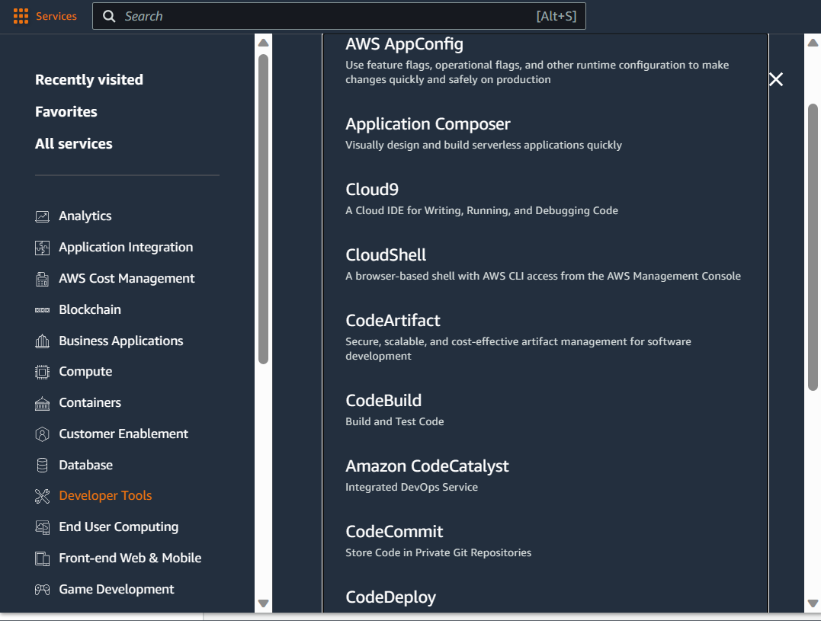

Click on Create Repository

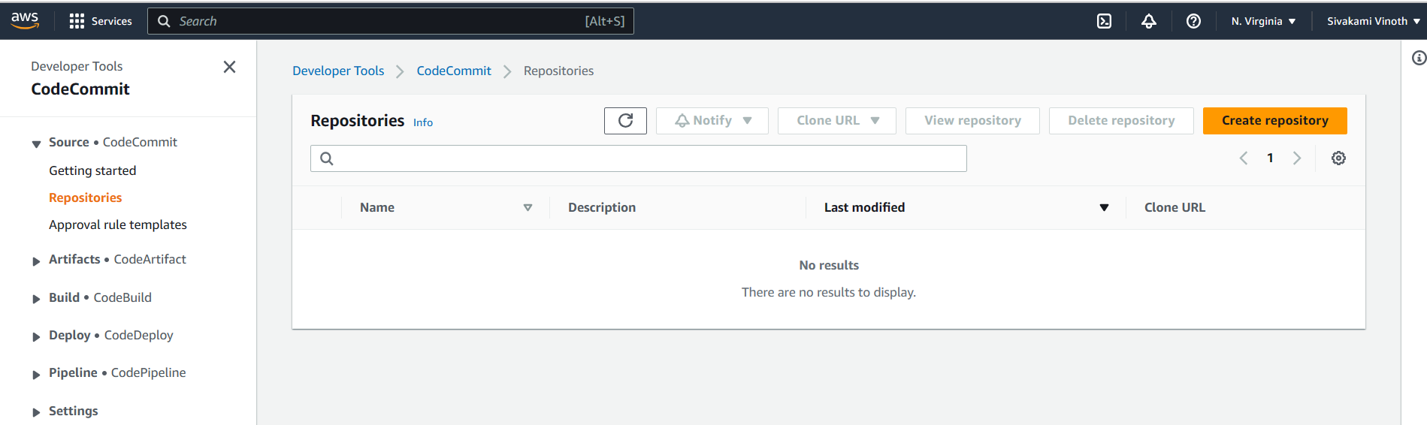

Enter the Repository name and click on Create

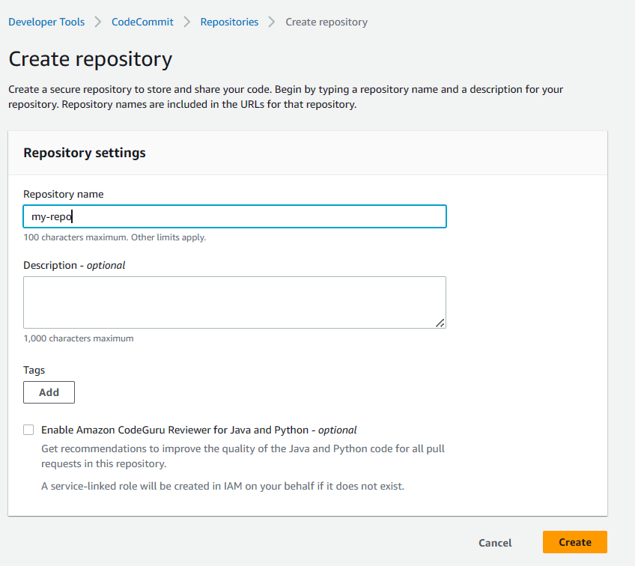

CodeCommit Repository created successfully

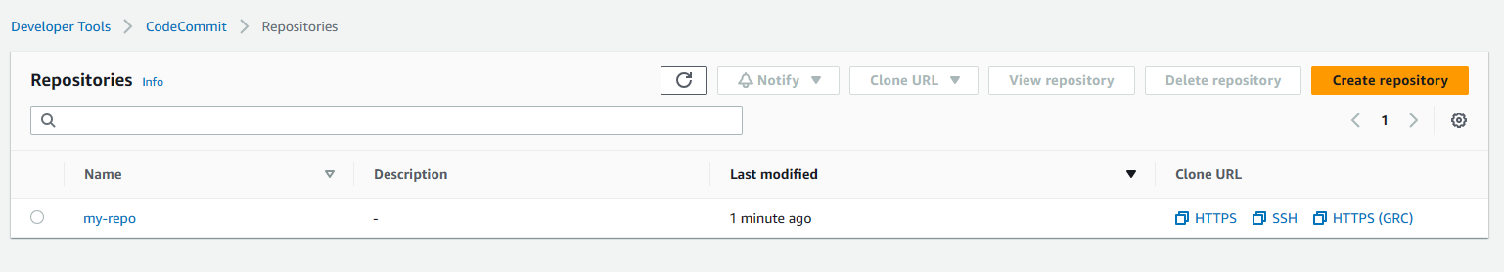

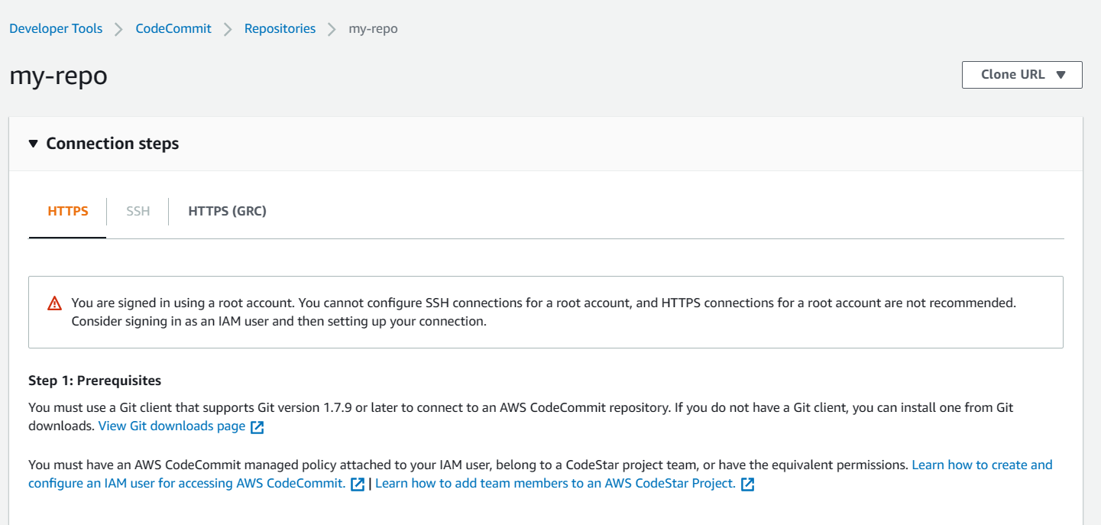

**Step:2** Create an IAM user with Administrator Acccess

Open the IAM services from AWS Management Console

Click on Add users

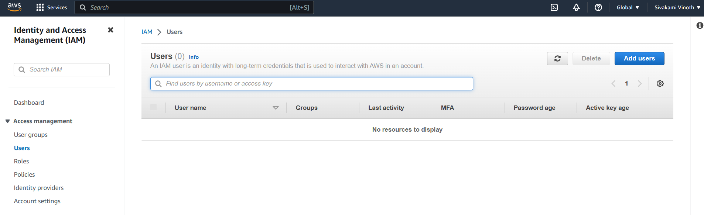

Enter the user name and select the option ‘provide user access to the AWS Management Console’. Also Select ‘Iwant to create an IAM user

Select Auto-generated password and click Next

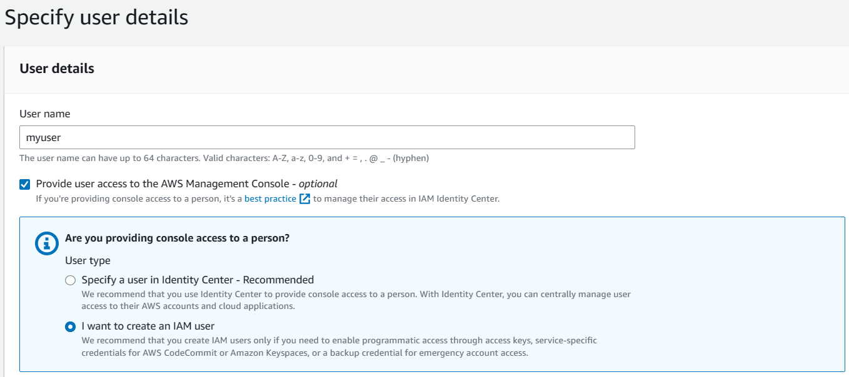

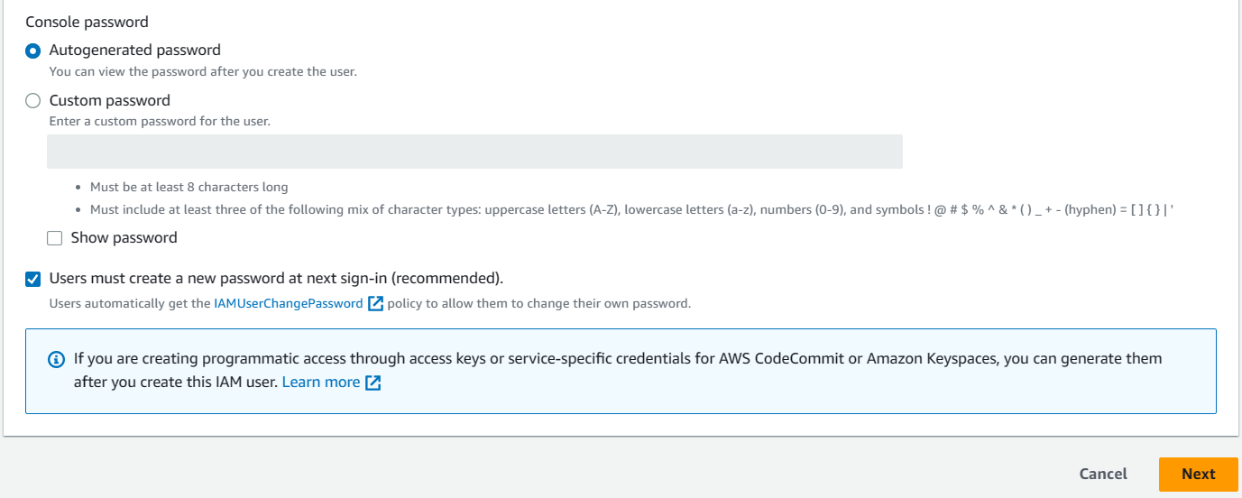

Click on Create group and create a user group ‘myusergroup’

Select the ‘AdministratorAccess’

Finally review and create the user

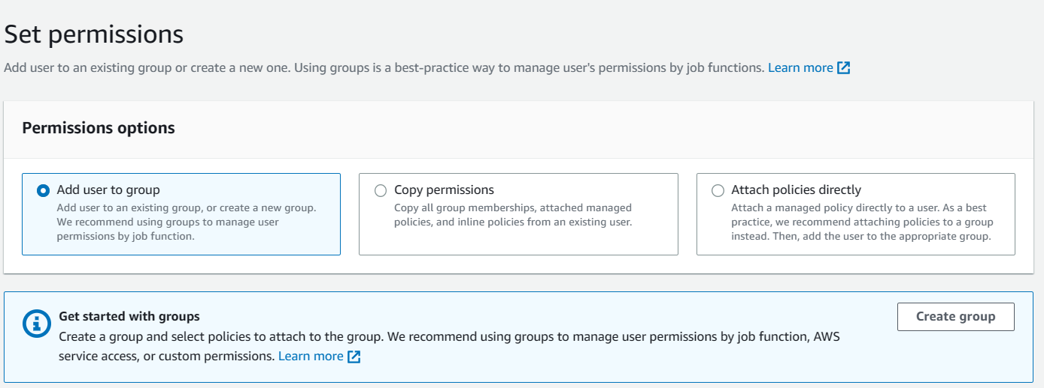

Download the password and save it for future use

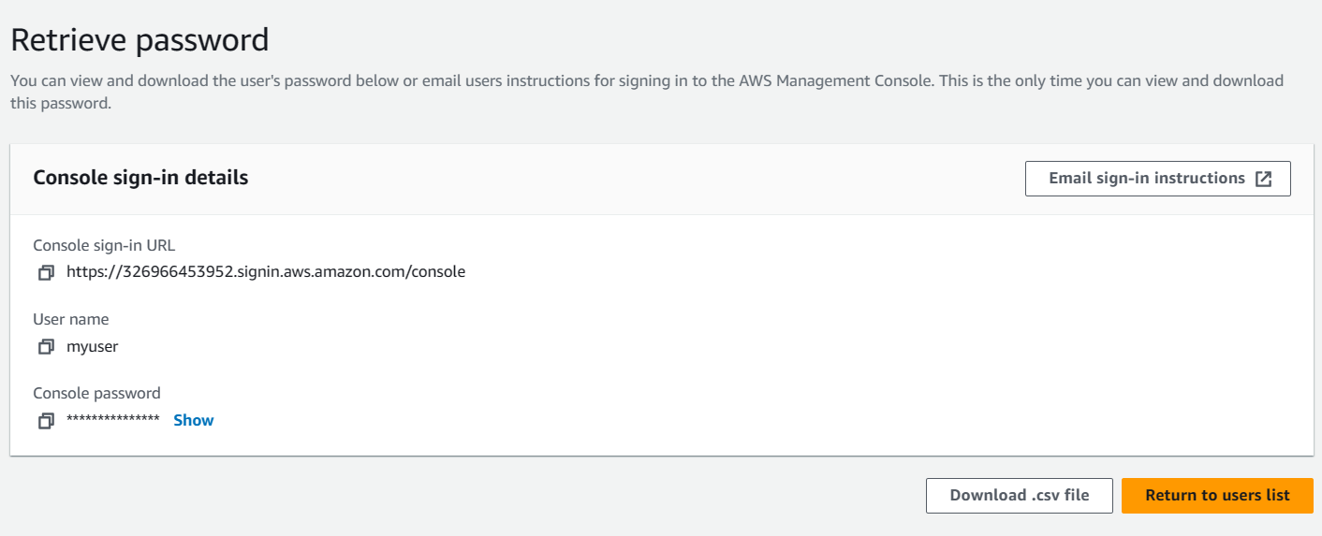

User creatied successfully

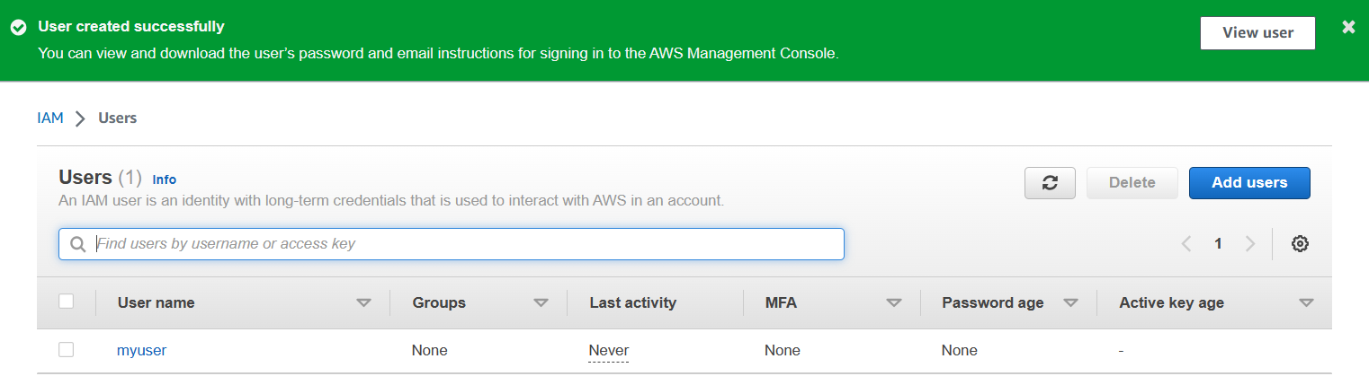

Open the IAM user created and Click on Security credentials

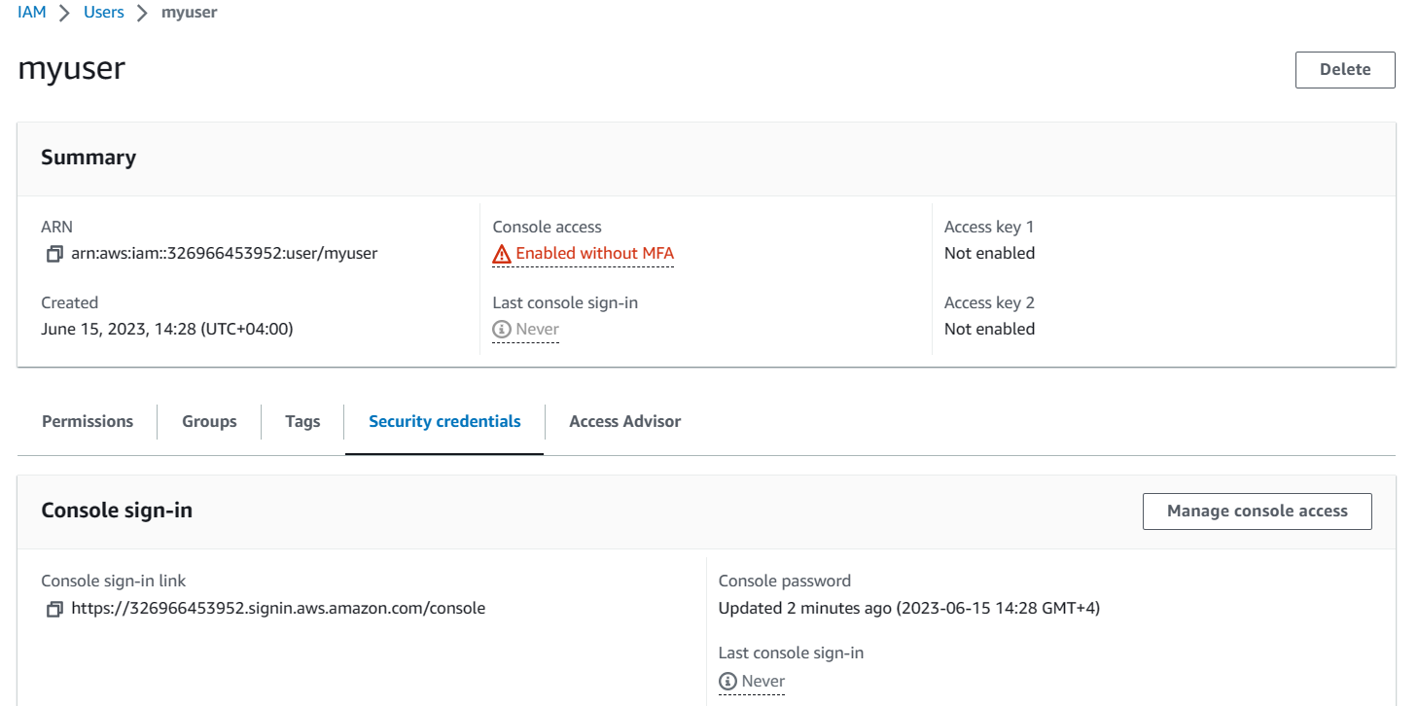

Move to HTTPS Git credentials for AWS CodeCommit and click on Generate credentials

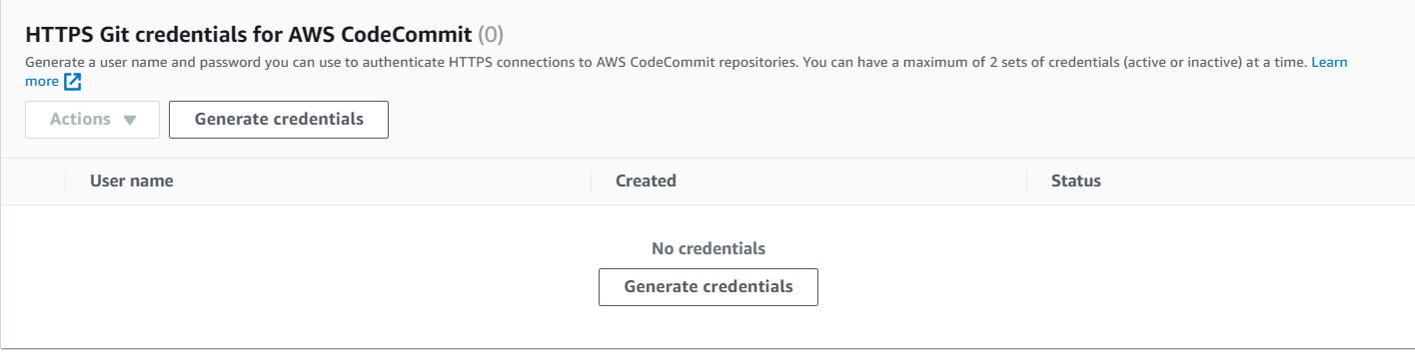

Download the credentials and save it for future use

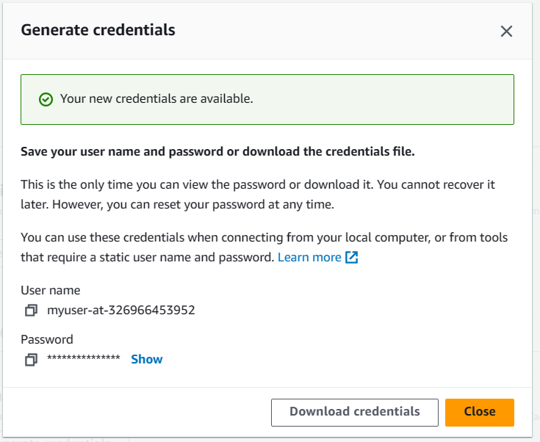

**Step:3** Create an EC2 Instance

Login to AWS Management console using the IAM user created

Open the EC2 Dashboard and create an EC2 Instance

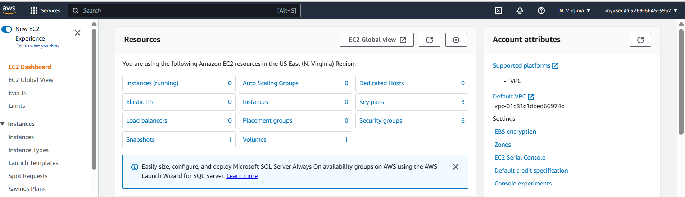

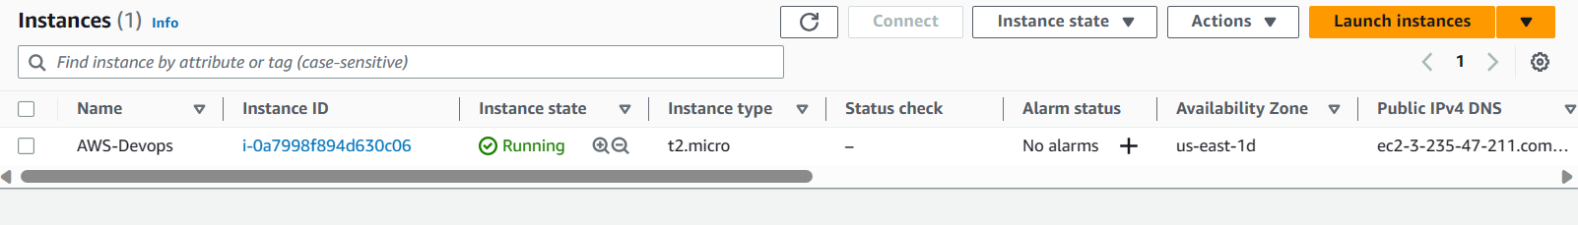

Connect to the EC2 Instance and run->sudo apt update

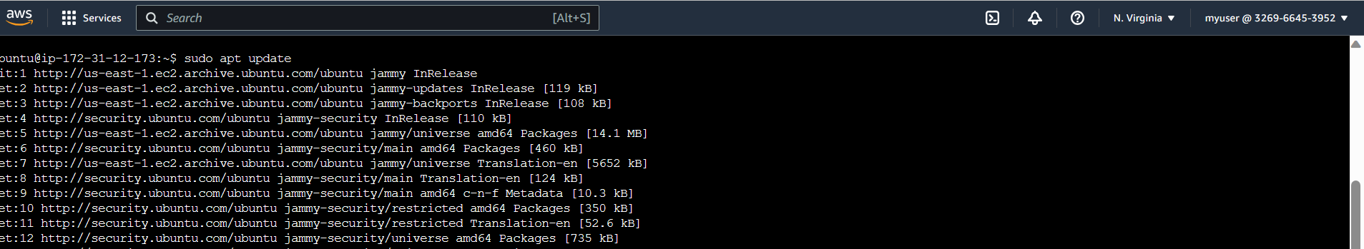

**Step:4 Copy the content from the Github to a local repository**

Open the Github account and copy the HTTPS url

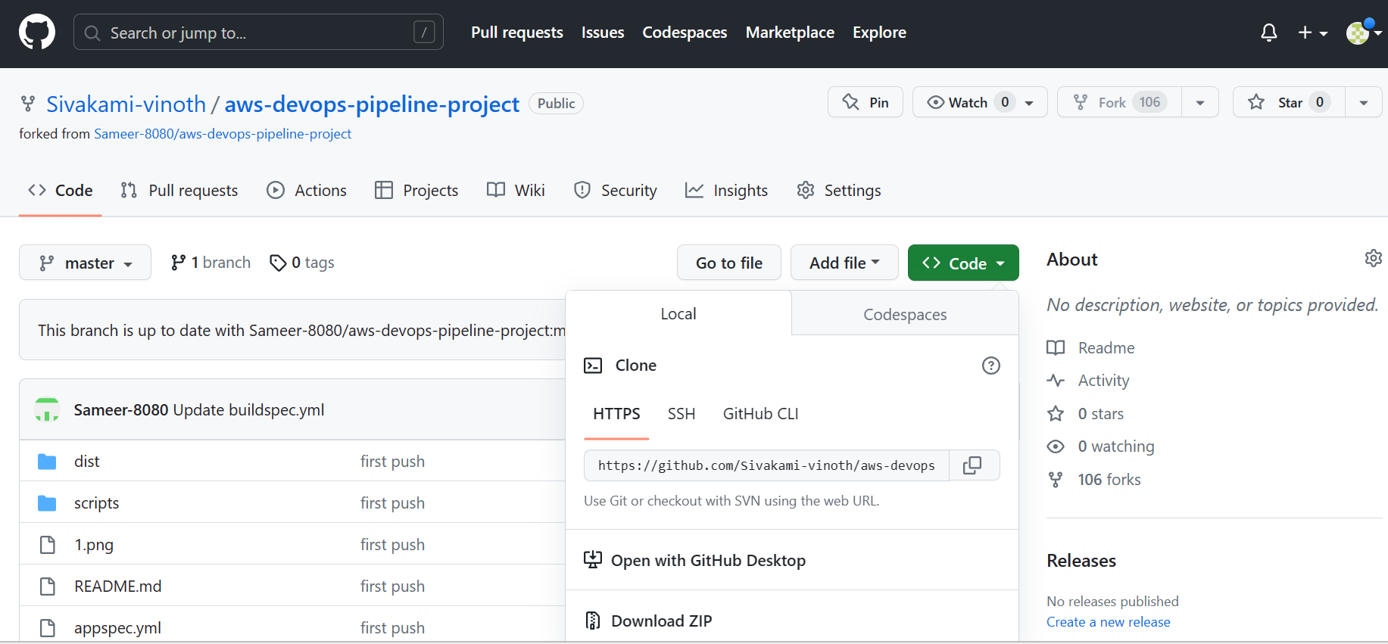

Run the command ->git clone –mirror <https://github.com/Sivakami-vinoth/aws-devops-pipeline-project.git> aws-devops (will copy the contents from github to the local repo aws-devops)

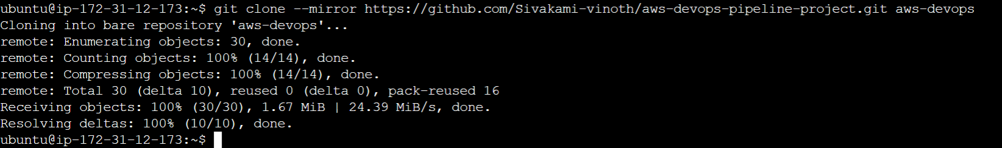

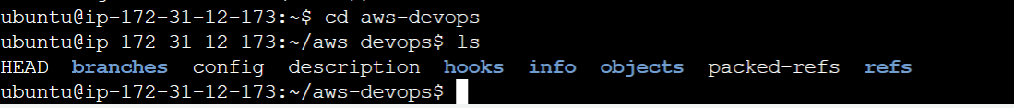

**Step:5 Push the contents to the CodeCommit Repository**

Open the CodeCommit and open the repository created

Copy the https url of the repository

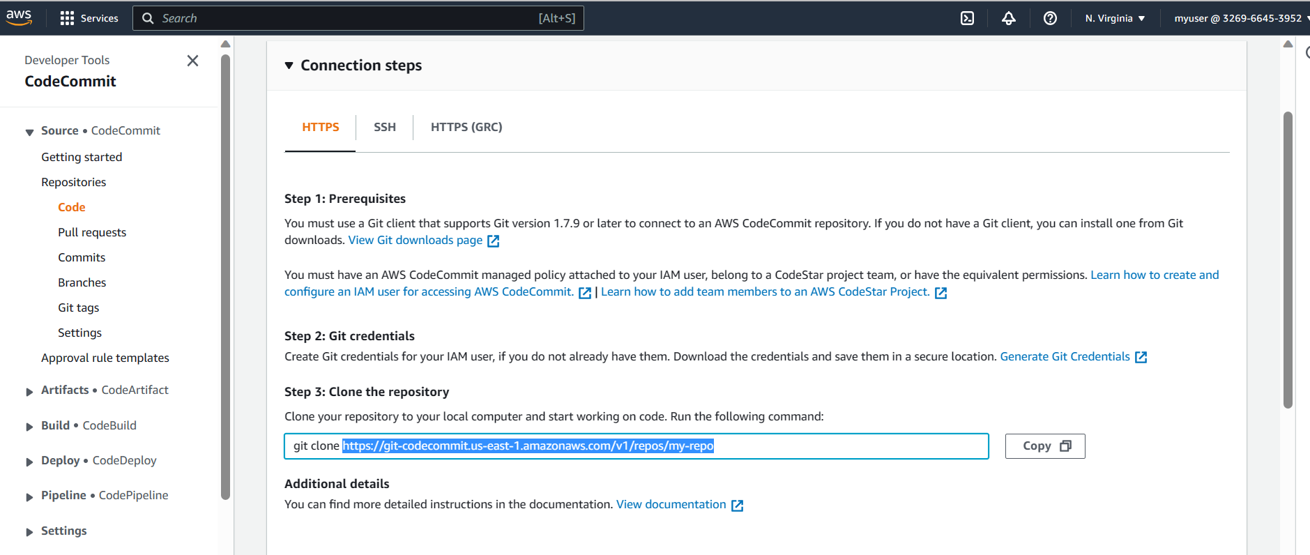

Run Commans-> git push <https://git-codecommit.us-east-1.amazonaws.com/v1/repos/my-repo>

Enter the AWS CodeCommit username and password genereted while creating the IAM user

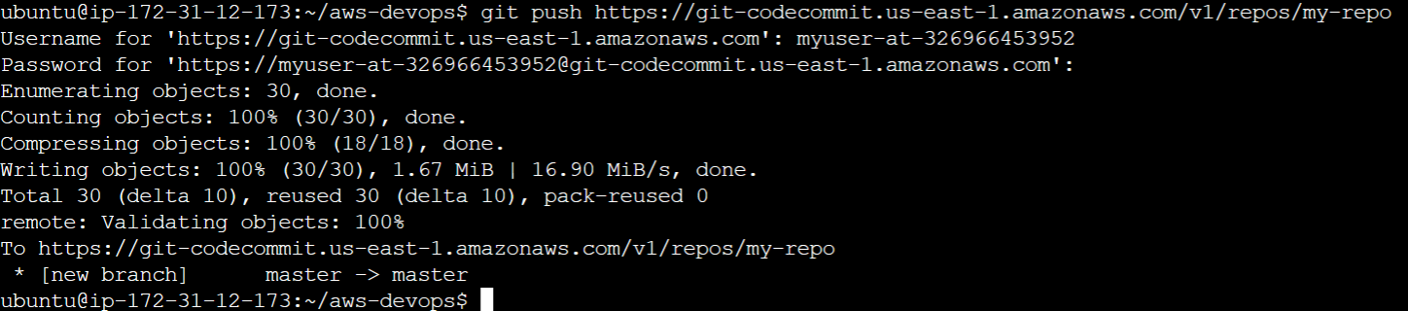

**Step:6 Check for the Github repository contents in the CodeCommit Repository**

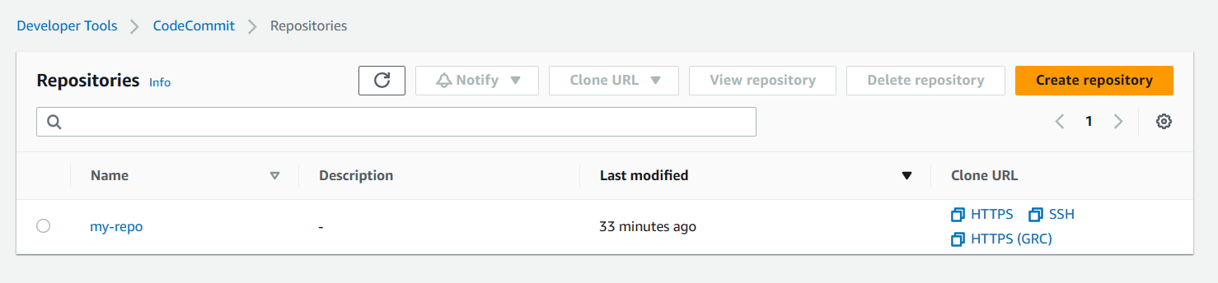

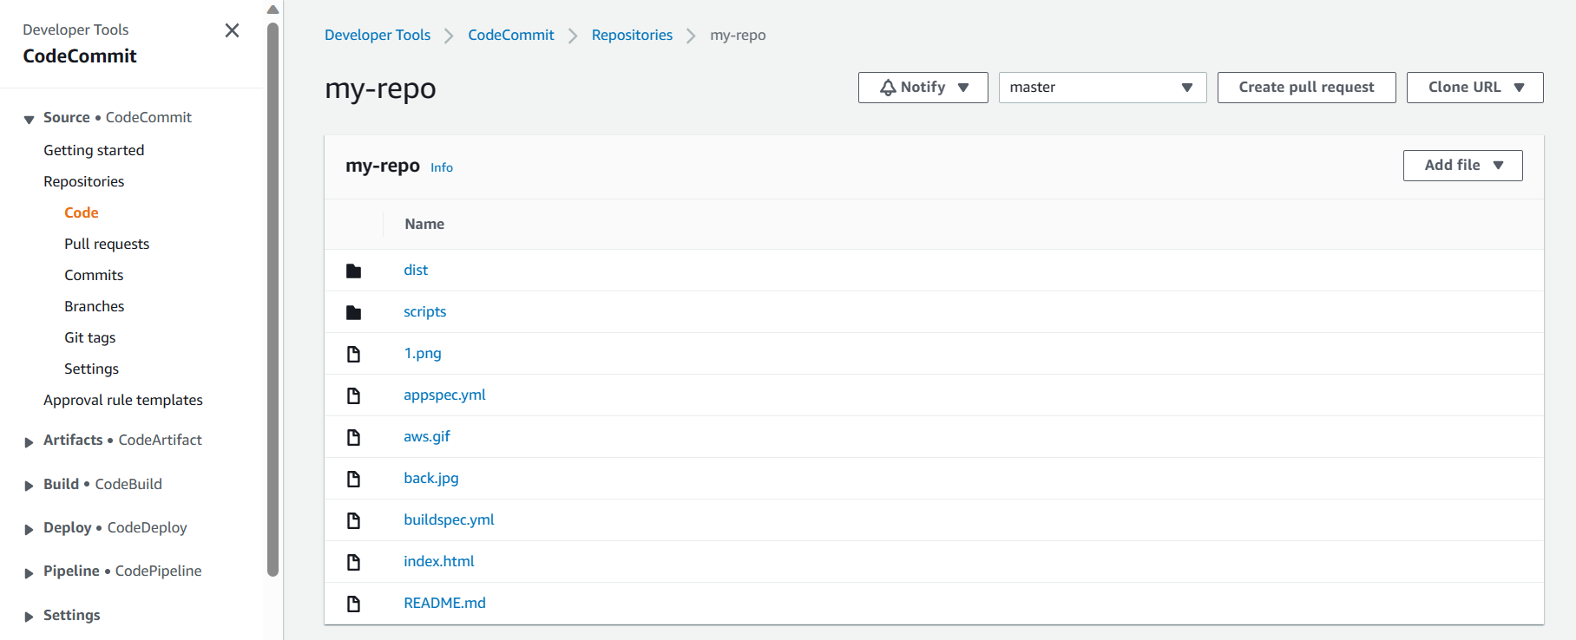

Successfully imported the Github Repository contents to the CodeCommit Repository

**Step:7 Create an IAM role with permissions policies**

AmazonEC2RoleforAWSCodeDeploy

AmazonSSMManagedInstanceCore

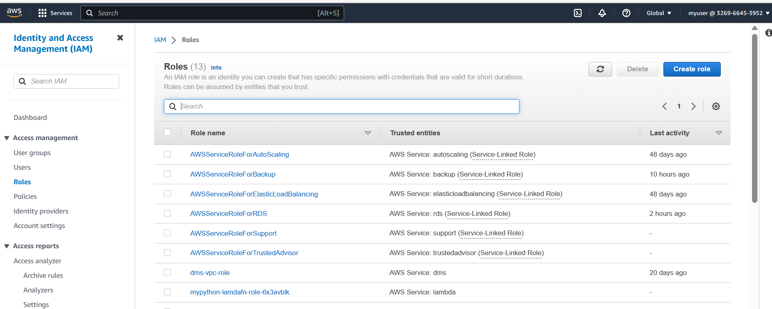

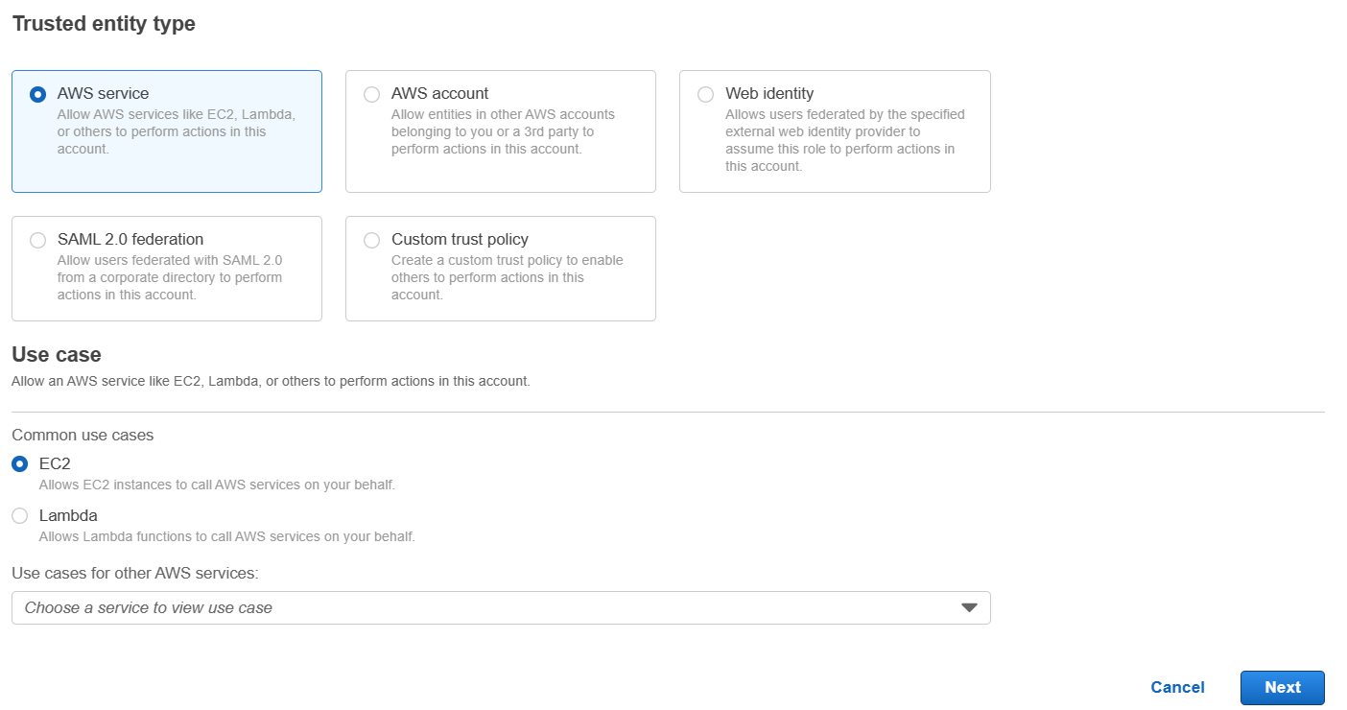

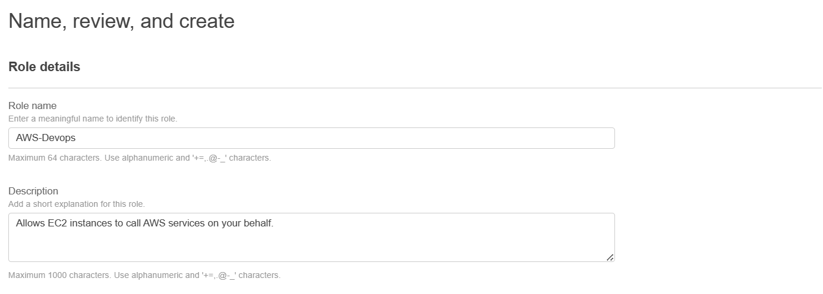

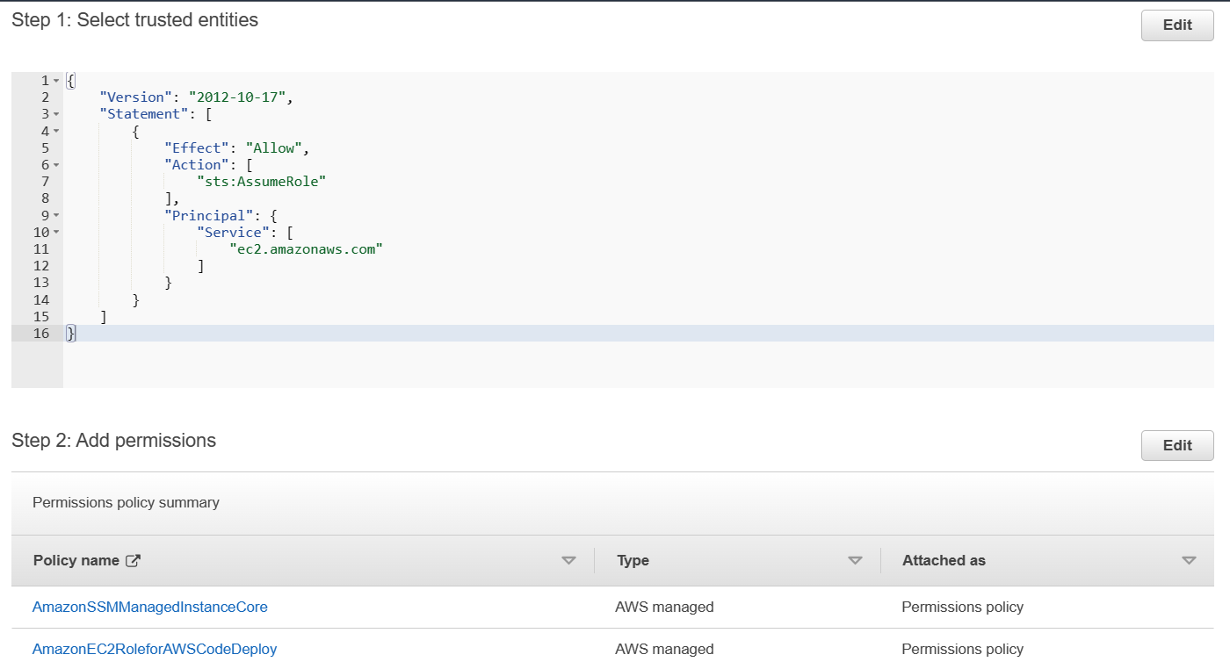

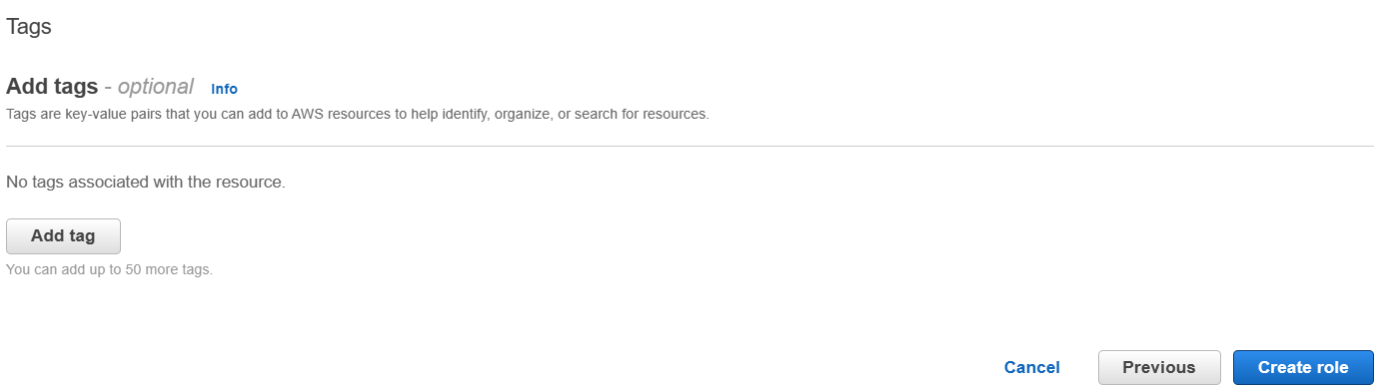

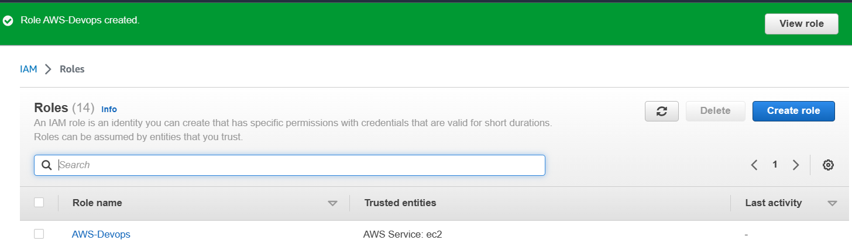

**Step:8 Create an EC2 Instance with the IAM Role Created to deploy the application**

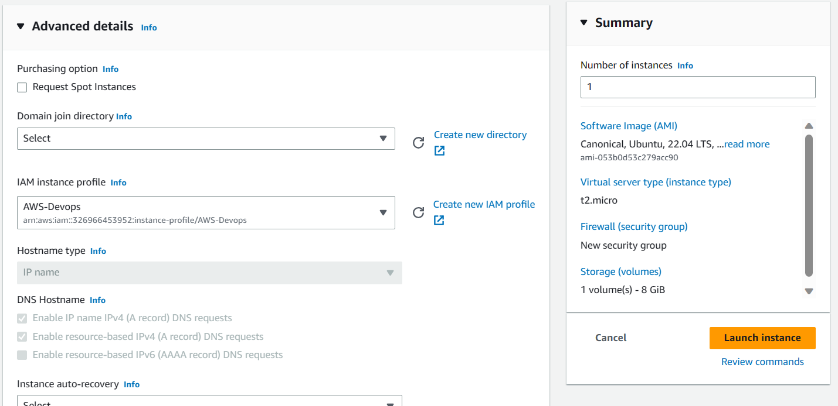

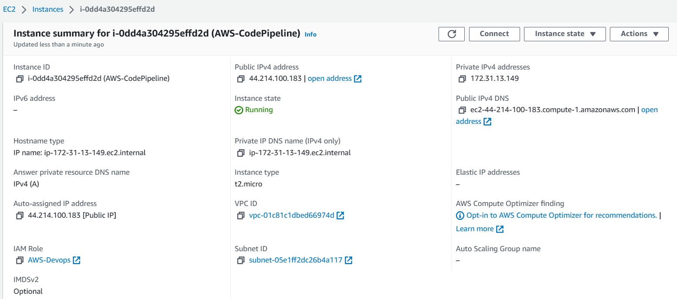

**Step:9 Connect to the EC2 Instance and run the following commands**

* sudo apt update
* sudo apt install ruby
* sudo apt install wget -y
* cd /home/ubuntu
* wget https://aws-codedeploy-us-east-2.s3.us-east-2.amazonaws.com/latest/install
* sudo chmod +x. /install
* sudo chmod +x ./install
* sudo ./install auto
* sudo service codedeploy-agent status

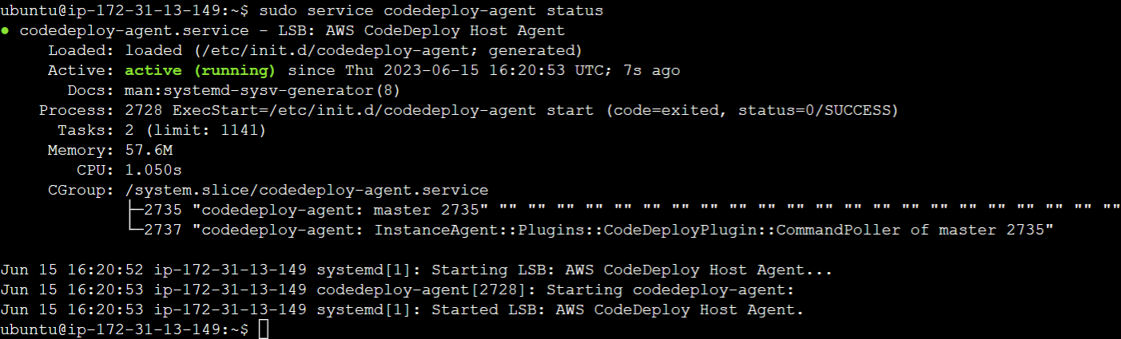

**Step:10 Create a CodeDeploy Application with the compute platform as EC2**

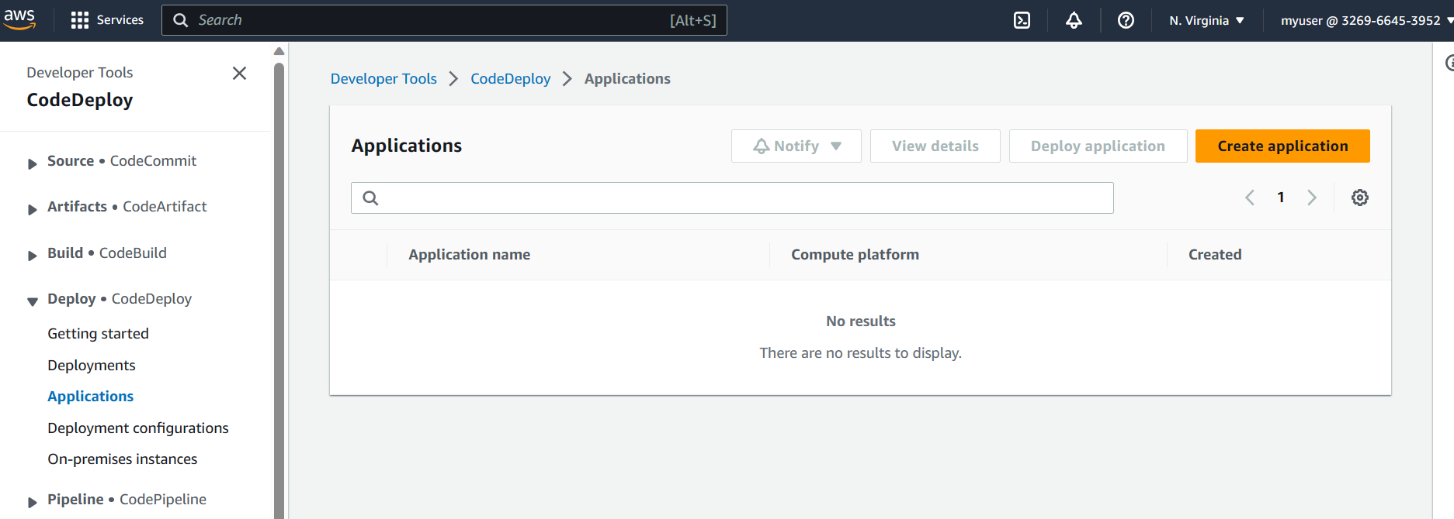

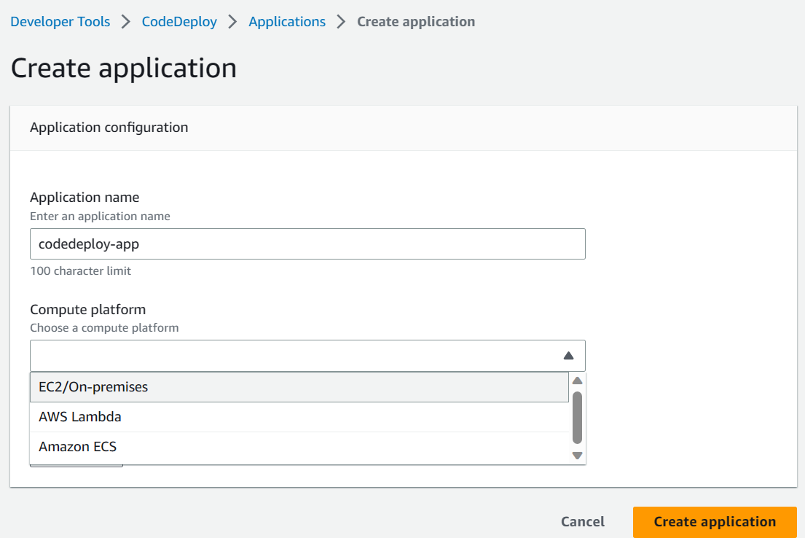

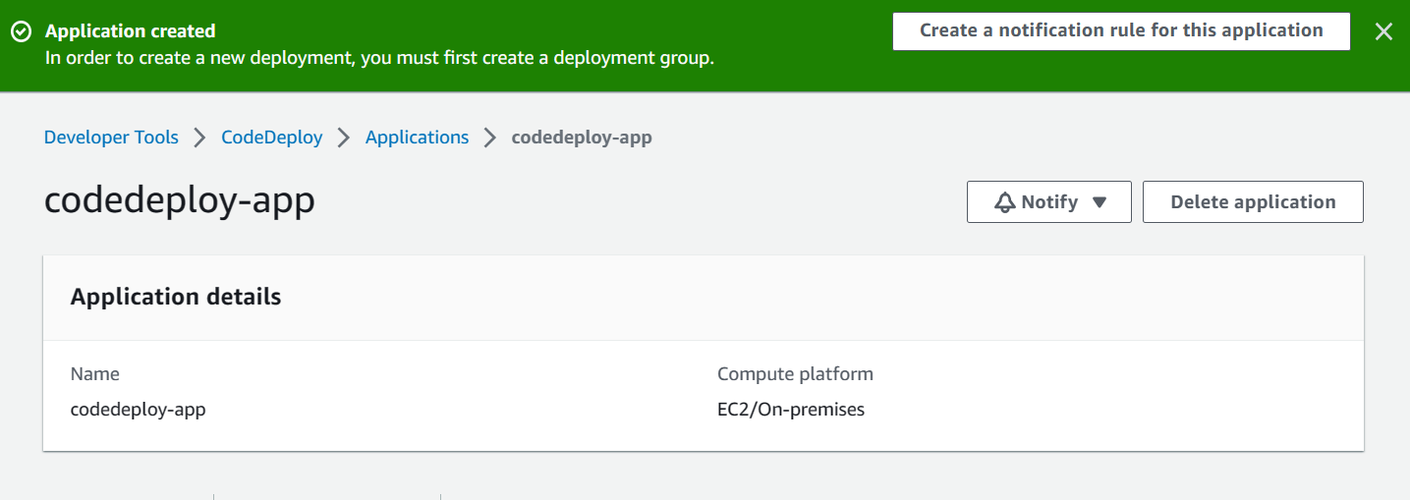

**Step:11 Select the deployment group with the created EC2 Instances**

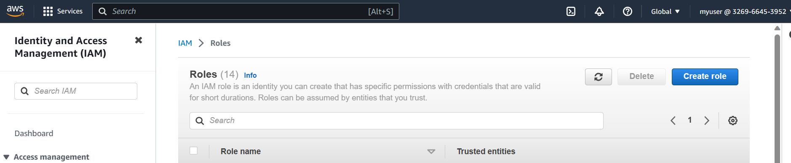

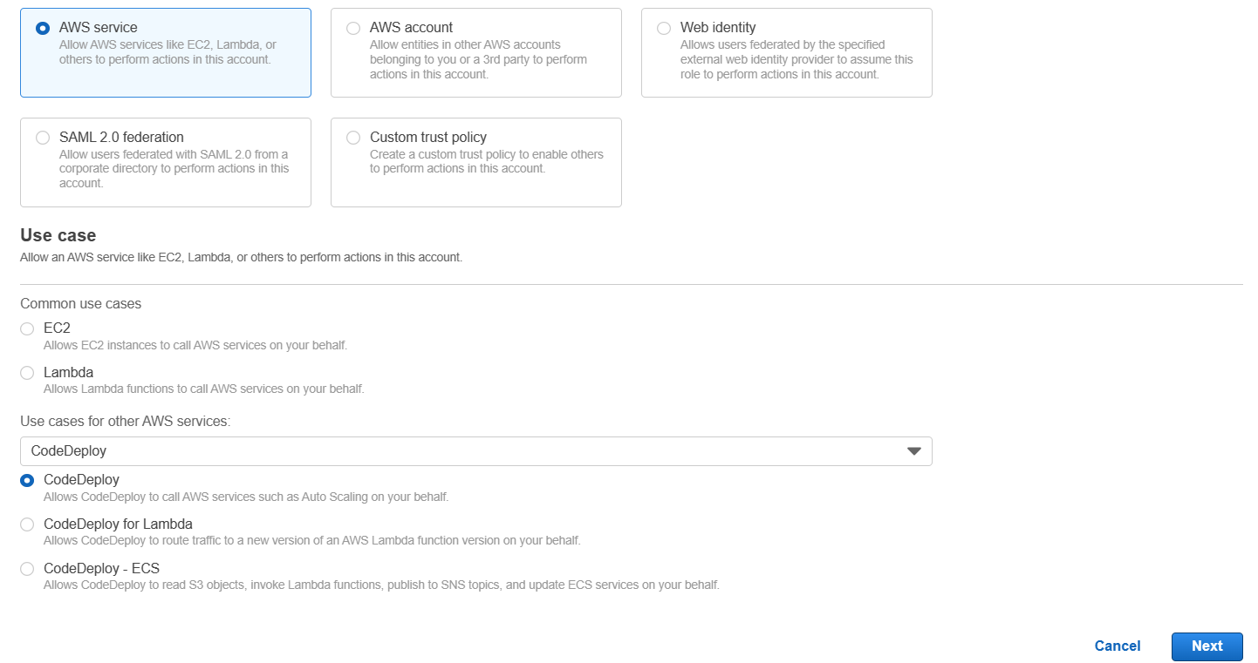

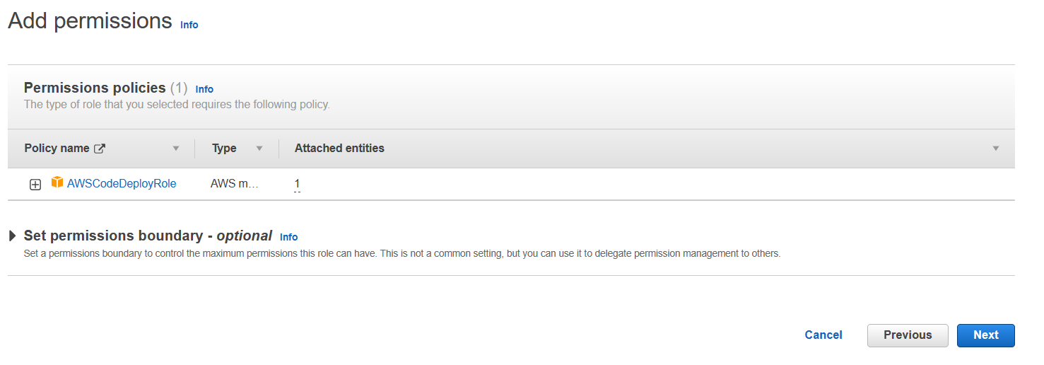

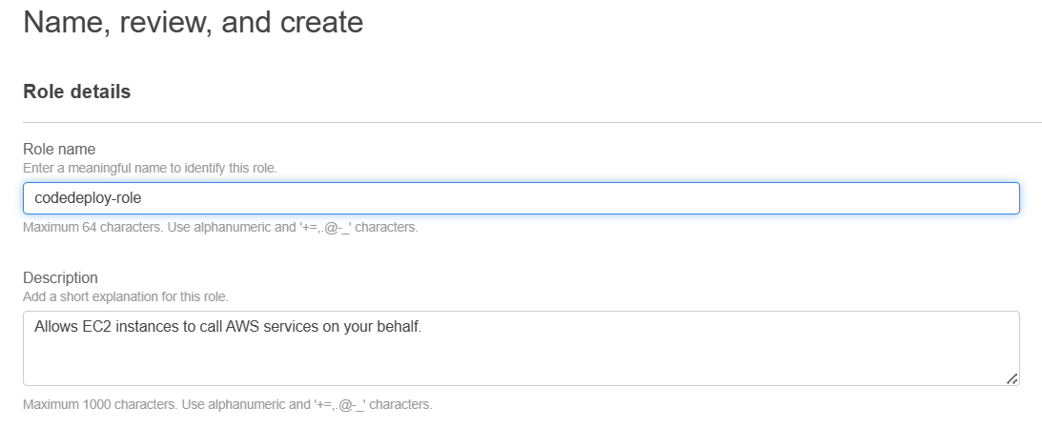

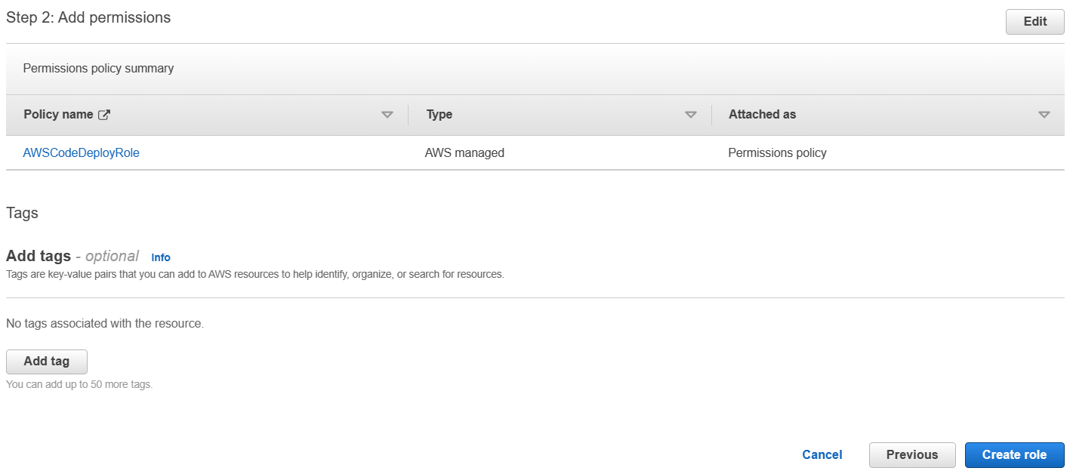

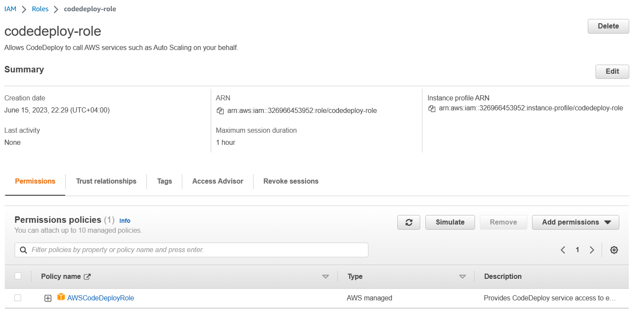

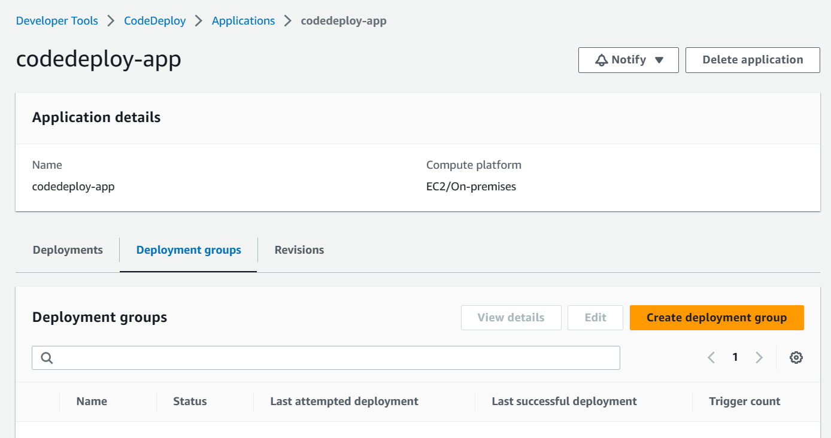

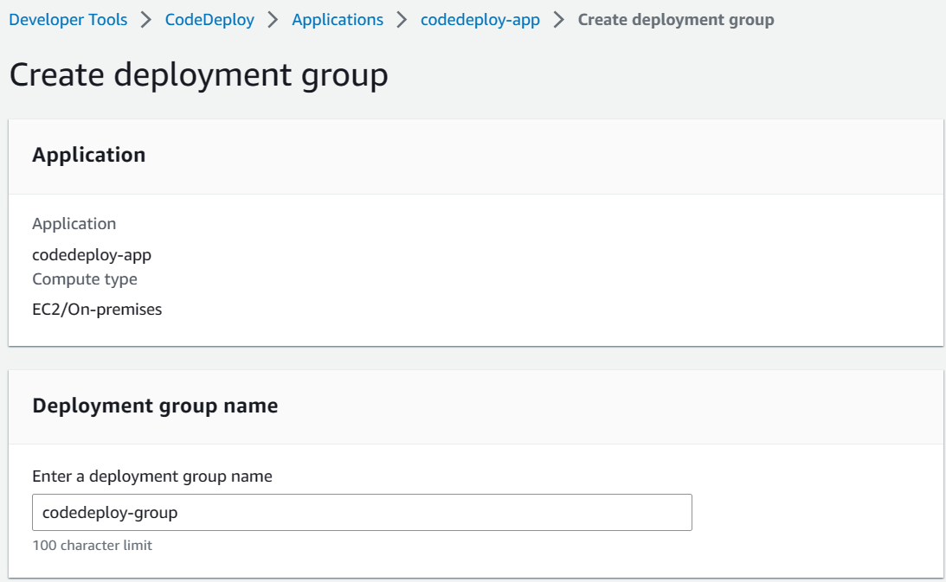

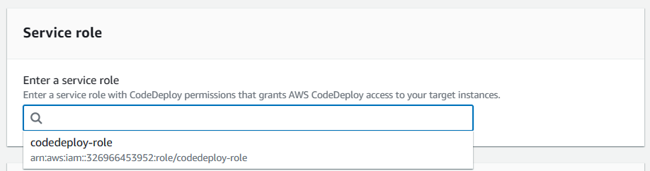

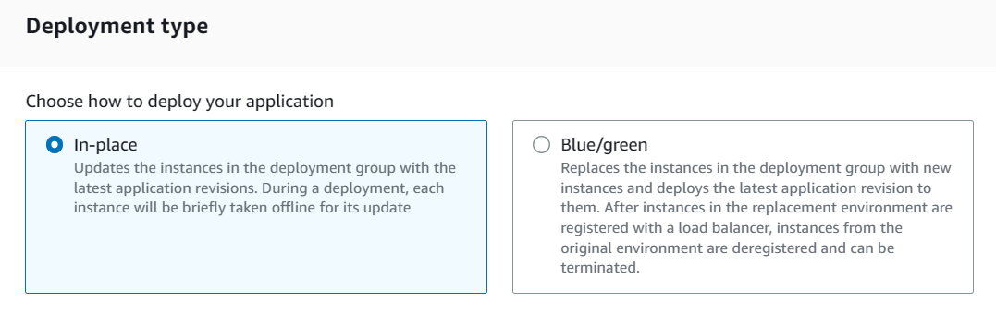

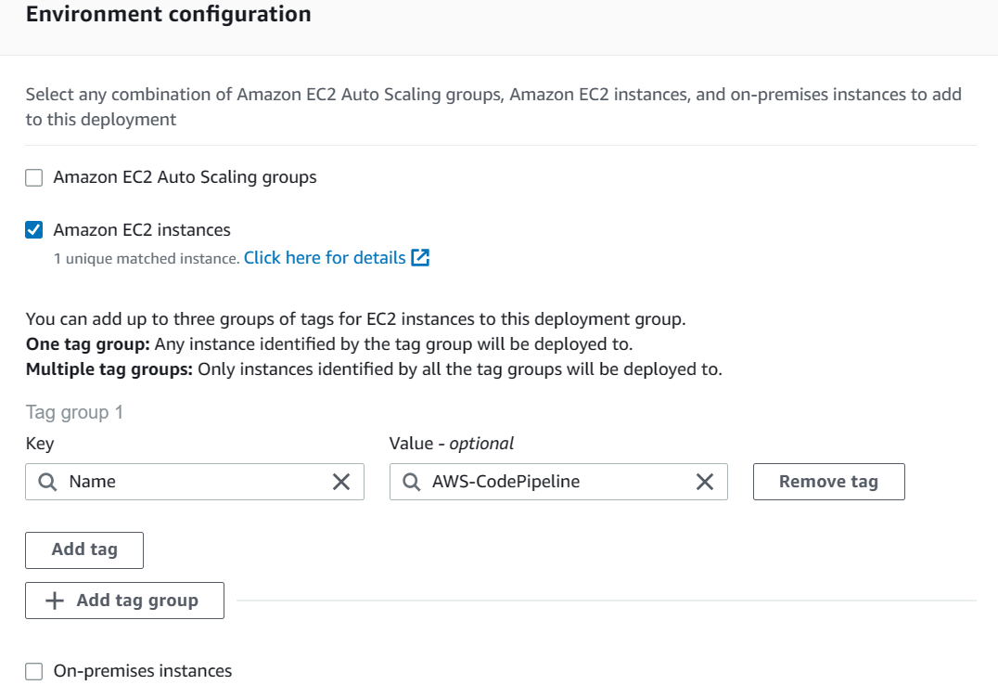

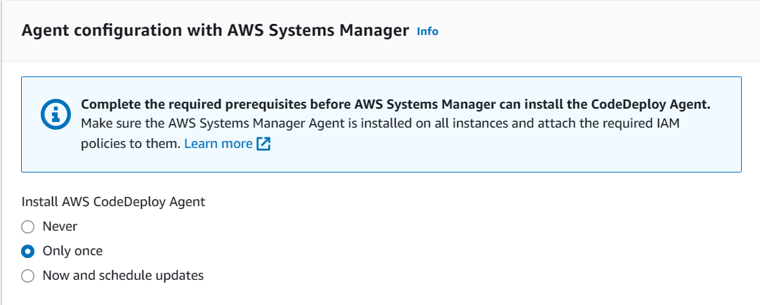

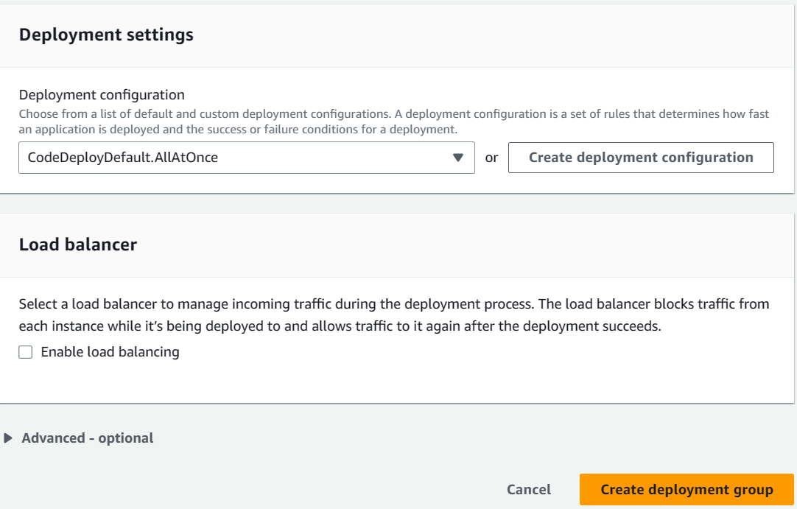

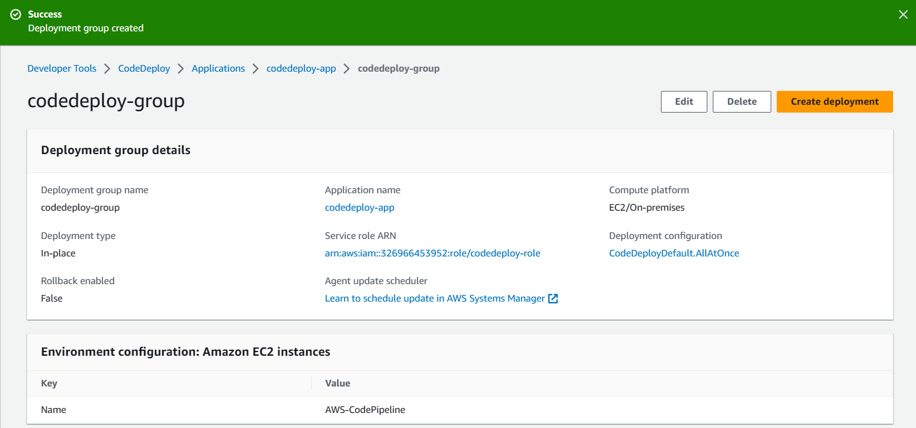

**Step:12 Create a pipeline using CodePipeline**

